# PYTHON REVIEW PROGRAMS

Review of python programming, Matrix operations, Programs using matplotlib /plotly/bokeh / seaborn for data visualisation and programs to handle data using pandas.

1. Find maximum value from a given matrix import numpy as np arr=np.array(([2,7,-1],[2,5,6],[2,8,5])) ab=np.max(arr) ac=np.min(arr) print("maximum=",ab) print("minimum=",ac)
2. Find the number of rows and columns of a given matrix import numpy as np arr=np.array(([2,7,6,7],[2,5,8,7],[2,8,9,8])) print("rows and columns") print(arr.shape)
3. Find the sum of values in a matrix import numpy as np arr=np.array(([2,7,6,7],[2,5,8,7],[2,8,9,8])) print("sum of all values in matrix") print(arr.sum())
4. Calculate the sum of diagonal elements of a numpy array. import numpy as np arr=np.array(([2,7,6],[2,5,8],[2,8,9])) print(arr)

print("the sum of diagonal element is:") print(np.trace(arr))

1. Python code to demonstrate matrix Add, Subtract, Division. import numpy as np arr=np.array(([2,7],[2,5],[2,8])) brr=np.array(([2,5],[5,7],[5,6])) print("a=",arr) print("b=",brr) print("sum of matrices \n",np.add(arr,brr)) print("subtract of matrices \n",np.subtract(arr,brr)) print("division of matrices \n",np.divide(arr,brr))

6.write a program to copy a text file to another file. name1 = input ("enter file to be read from:") name2 = input("enter file to be appended to:") fin = open(name1,"r") data2 = fin.read() fin.close() fout = open(name2,"a") fout.write(data2) fout.close()

7.write a program to count the number of lines in a file. fname = input("enter a file name") num_lines= 0 with open(fname,'r') as f:

for line in f: num_lines += 1 print("no of lines") print(num_lines)

8.write a program to count the frequency of each word from a file from collections import Counter def word_count(fname): with open(fname) as f:

return Counter(f.read().split()) print("Number of words in the file :",word_count("text.txt")) 8.write a program to append a file with the content of another file. name1 = input("enter file to be read from:") name2 = input("enter file to be appended from:") fin = open(name1,"r") data2 = fin.read() fin.close() fout = open(name2,"a") fout.write(data2) fout.close()

10.write a program to compare two files.

import filecmp f1 = input("enter a first ") f2 = input("enter a second ") result = filecmp.cmp(f1,f2) print(result) result = filecmp.cmp(f1,f2,shallow=false) print(result)

11.write a program to delete a sentence from the specified position in a file. try: with open('months.txt', 'r') as fr:

lines = fr.readlines() ptr = 1 with open('months.txt', 'w') for line in lines: if ptr != 5: fw.write(line) ptr += 1 print("Deleted") except:

print("Oops! something error")

**IRIS**

**import** numpy **as** np **import** pandas **as** pd **import** matplotlib.pyplot **as** plt data**=**pd**.**read_csv("Iris.csv")

plt**.**figure(figsize**=**(10,3)) x**=**data["SepalLengthCm"] plt**.**hist(x,bins**=**20,color**=**"green") plt**.**xlabel("SepalLength in cm") plt**.**ylabel("count") plt**.**show

Out[11]:

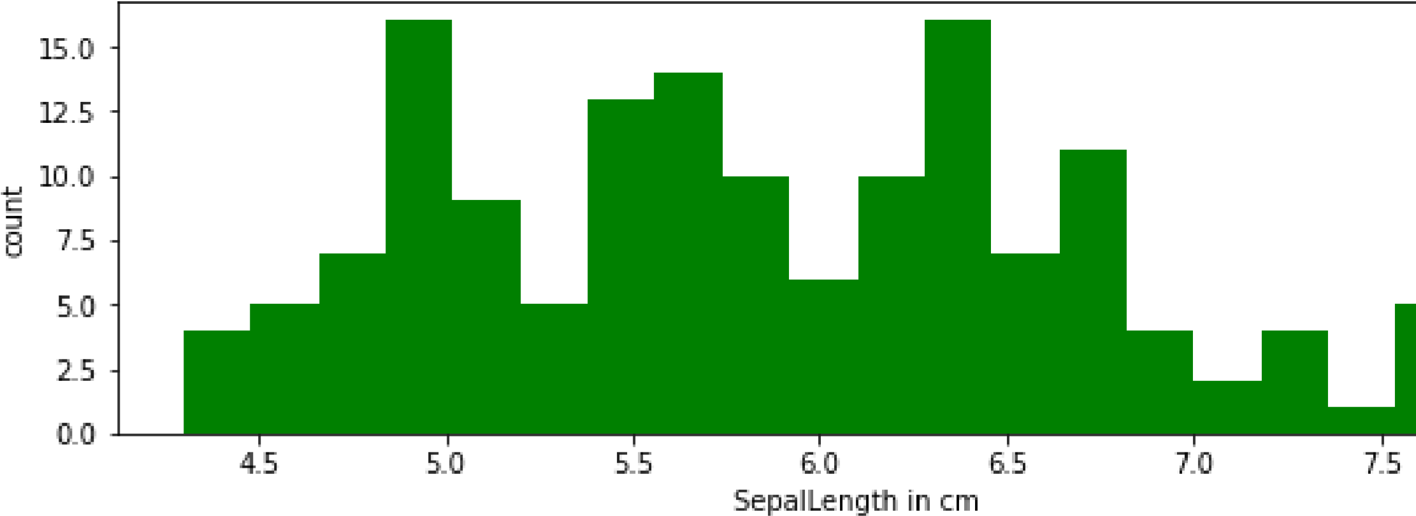<function matplotlib.pyplot.show(close=None, block=None)>

In [ ]:

In [8]:

**import** numpy **as** np **import** pandas **as** pd **import** matplotlib.pyplot **as** plt data**=**pd**.**read_csv("Iris.csv") print(data**.**head(10))

Id SepalLengthCm SepalWidthCm PetalLengthCm PetalWidthCm Species 0 1 5.1 3.5 1.4 0.2 Iris-setosa

1. 2 4.9 3.0 1.4 0.2 Iris-setosa
2. 3 4.7 3.2 1.3 0.2 Iris-setosa
3. 4 4.6 3.1 1.5 0.2 Iris-setosa
4. 5 5.0 3.6 1.4 0.2 Iris-setosa
5. 6 5.4 3.9 1.7 0.4 Iris-setosa
6. 7 4.6 3.4 1.4 0.3 Iris-setosa
7. 8 5.0 3.4 1.5 0.2 Iris-setosa
8. 9 4.4 2.9 1.4 0.2 Iris-setosa
9. 10 4.9 3.1 1.5 0.1 Iris-setosa

In [10]:

# import numpy as np import pandas as pd

**import** matplotlib.pyplot **as** plt Iris**=**pd**.**read_csv("Iris.csv") plt**.**plot(Iris["SepalLengthCm"],"r--")

plt**.**show

Out[10]: <function matplotlib.pyplot.show(close=None, block=None)>

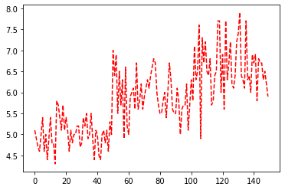

In [12]:

**import** numpy **as** np **import** pandas **as** pd **import** matplotlib.pyplot **as** plt iris**=**pd**.**read_csv("Iris.csv")

iris**.**plot(kind**=**"scatter",x**=**"SepalLengthCm",y**=**"PetalLengthCm") plt**.**grid() plt**.**show()

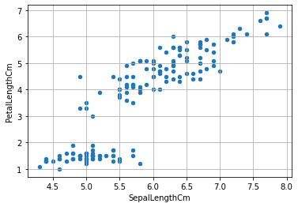

In [13]:

**import** numpy **as** np **import** pandas **as** pd **import** matplotlib.pyplot **as** plt iris**=**pd**.**read_csv("Iris.csv") plt**.**figure(figsize**=**(10,3))

iris**.**boxplot()

Out[13]:

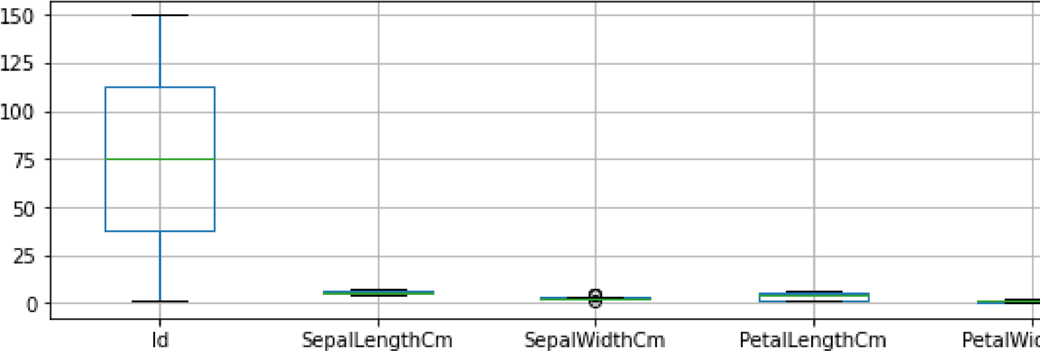<AxesSubplot:>

In [ ]:

# Bird dataset

**import** numpy **as** np **import** pandas **as** pd **import** matplotlib.pyplot **as** plt data**=**pd**.**read_csv("data_csv.csv") plt**.**figure(figsize**=**(10,3))

data**.**boxplot()

Out[1]:

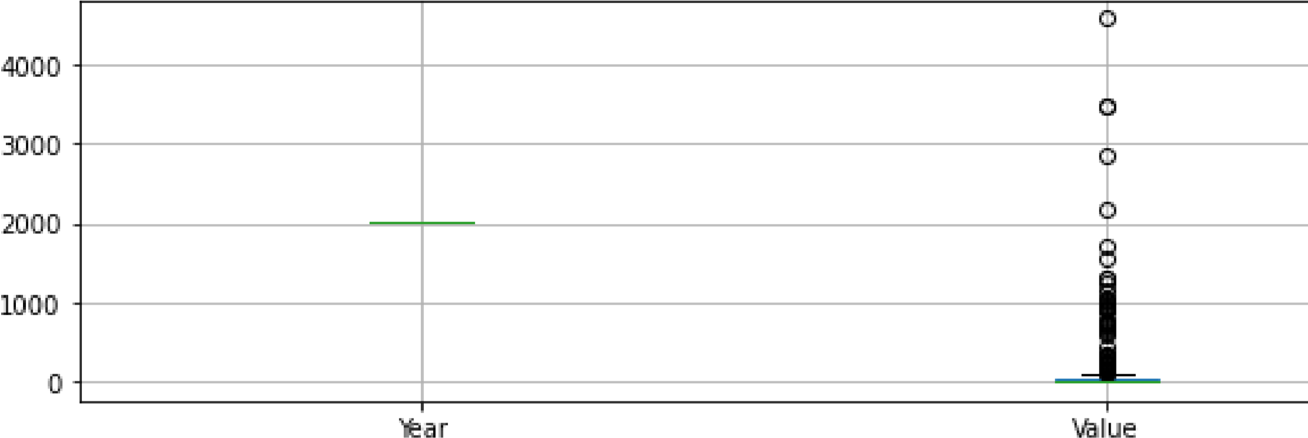<AxesSubplot:>

In [2]:

**import** numpy **as** np **import** pandas **as** pd **import** matplotlib.pyplot **as** plt data**=**pd**.**read_csv("data_csv.csv") data**.**plot(kind**=**"scatter",x**=**"Year",y**=**"Value") plt**.**grid() plt**.**show()

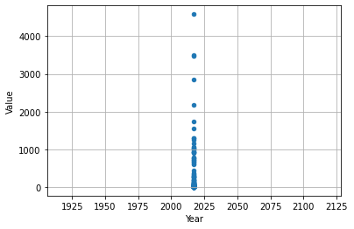

In [3]:

**import** numpy **as** np **import** pandas **as** pd **import** matplotlib.pyplot **as** plt data**=**pd**.**read_csv("data_csv.csv") plt**.**figure(figsize**=**(10,3)) x**=**data["Value"]

plt**.**hist(x,bins**=**20,color**=**"green") plt**.**xlabel("Value") plt**.**ylabel("Year") plt**.**show

Out[3]:

<function matplotlib.pyplot.show(close=None, block=None)>

In [8]:

**import** numpy **as** np **import** pandas **as** pd **import** matplotlib.pyplot **as** plt data**=**pd**.**read_csv("data_csv.csv") plt**.**plot(data["Country Code"],"g--")

plt**.**show

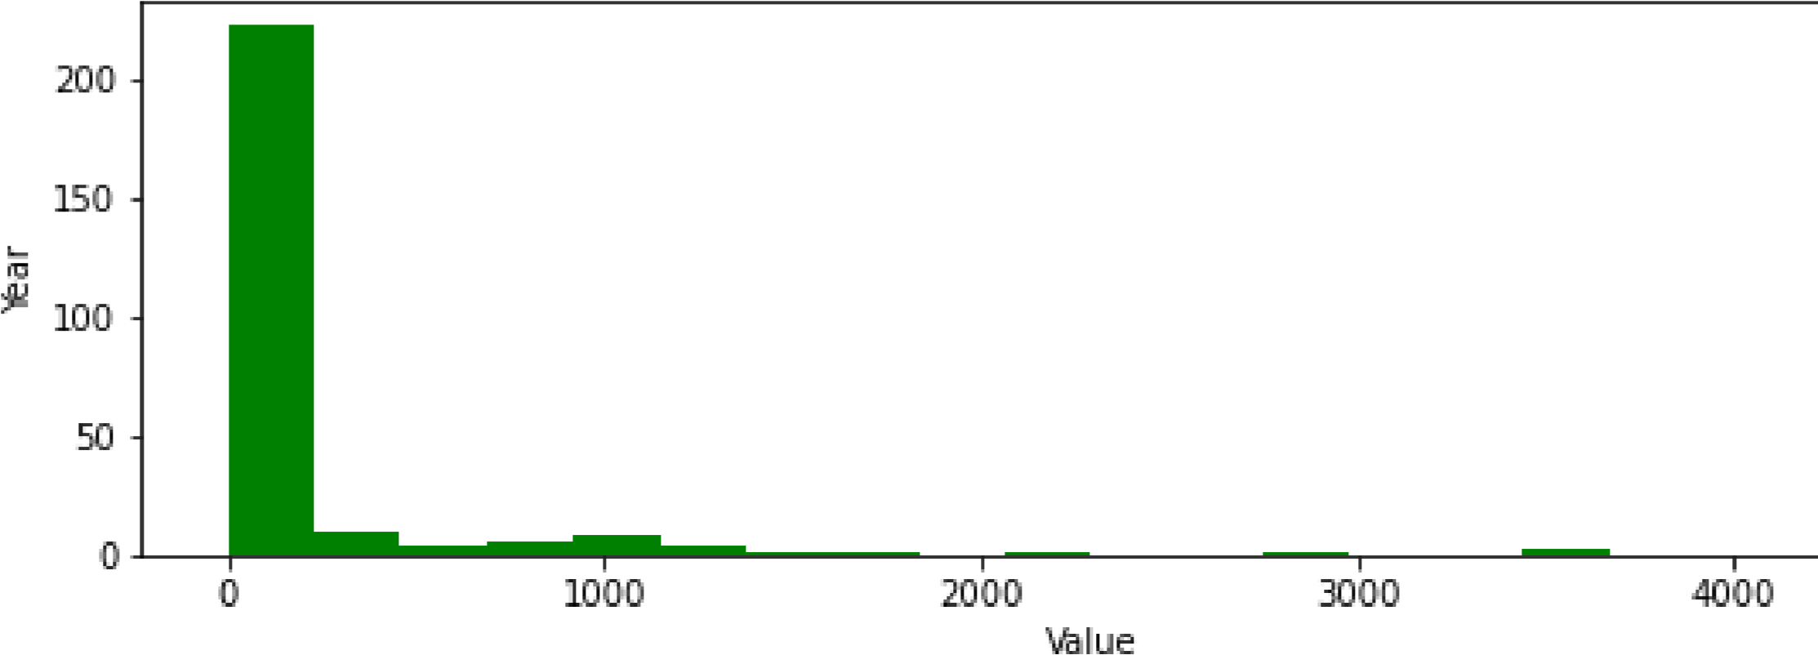Out[8]: <function matplotlib.pyplot.show(close=None, block=None)>

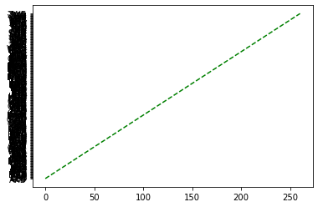

In [7]:

**import** numpy **as** np **import** pandas **as** pd **import** matplotlib.pyplot **as** plt data**=**pd**.**read_csv("data_csv.csv")

print(data**.**head(10))

Country Name Country Code Year Value

1. Arab World ARB 2017 310
2. Caribbean small states CSS 2017 76
3. Central Europe and the Baltics CEB 2017 133
4. Early-demographic dividend EAR 2017 1727
5. East Asia & Pacific EAS 2017 1166
6. East Asia & Pacific (excluding high income) EAP 2017 787
7. East Asia & Pacific (IDA & IBRD countries) TEA 2017 755
8. Euro area EMU 2017 213
9. Europe & Central Asia ECS 2017 678
10. Europe & Central Asia (excluding high income) ECA 2017 356

In [ ]: